1. **Difference between HTTP1.1 and HTTP2**

CLIENT – SERVER COMMUNICATION STEPS

* URL (hostname.domainname) typed in address bar
* DNS - convert domain name to IP address
* TCP connection (3 way handshake and TLS handshake)
* HTTPS(s) request with methods (get/put/post/delete)
* Server response (HTML/CSS/JS) with return code (100 -599)
* Parsed HTML, CSS and javascript get executed by rendering engine in browser
* Contents get viewed in client browser

TCP connection

3 - way handshake

* Client send synchronization request to server
* Server respond with acknowledgement and synchronization request
* Client respond with acknowledgement.

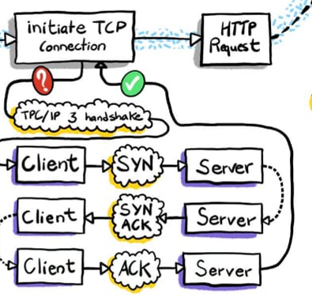

TLS handshake

* Client hello – client share supported TLS version and list of Cipher suites in order of preference.

(Note – TLS version 1.2 – majorly supported, TLS version 1.3 – latest and released on 2018, Cipher suites – set of algorithm contains key exchange algorithm, bulk encryption algorithm, Message Authentication Code (MAC) algorithm)

* Server hello – Server respond with chosen cipher suite and share digital certificates with public key
* Client generate encrypted session key using public key received from server and send session key to server.
* Server decrypt session key using private key.
* Client server communication established using session key.

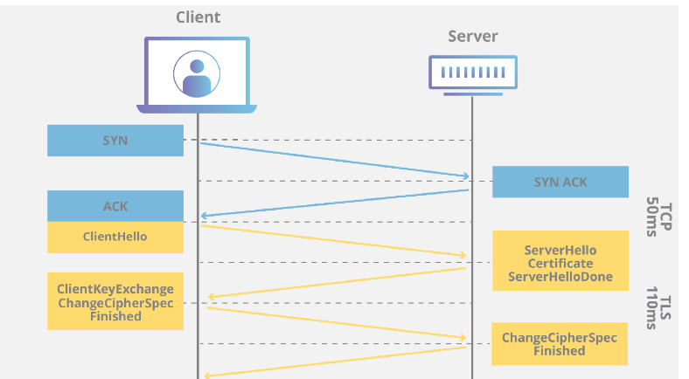

HTTP(S) OVERVIEW

* Protocol used to promote communication between client(browser) and server.
* Client submit http request and server respond with resource such as HTML pages, images, stylesheets, scripts and other contents.
* HTTP operates at port – 80 and HTTPS operates at port – 443
* HTTPS promote encrypted (secured) form of data transfer.

HTTP 1.1 vs HTTP 2

* HTTP1.1 released on 1997 and HTTP 2 released on 2015 and HTTP 3 released on 2022.
* As size and number of transfer contents from server getting increased in recent days which leads to latency issue. In order to reduce transfer time between client and server HTTP2 was introduced.

DATA TRANSFER

* HTTP1.1 transfers data in normal textual format while HTTP2 transfer data in encoded binary format.

HEAD OF LINE BLOCKING - MULTIPLEXING

* In HTTP1.0 for each request a TCP connection was established, HTTP1.1 solve this issue using **pipelining** where TCP connection kept open until directed to close. It allows client to send multiple request in single connection.
* HTTP1.1 faced **head of line block**, where request at head of queue may not receive response resource from server within stipulated time which lead to bottleneck and block of all request behind it. In HTTP2 head of line blocking issue gets solved by **multiplexing.**
* Connection get break down to Stream -> message -> frame (encoded with tag of particular stream) get transmitted and reassembled at destination which avoids head of line blocking by parallel transmission of streams.

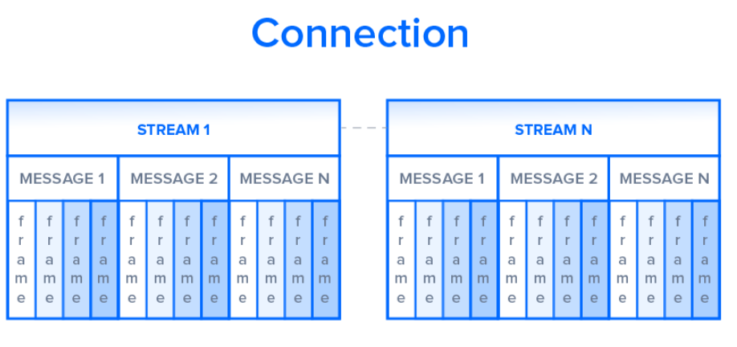

STREAM PRIORITIZATION

* Request can be prioritized by assigning Stream ID (SID) and Parent ID (PID) and Weight (wt – 1 to 256).

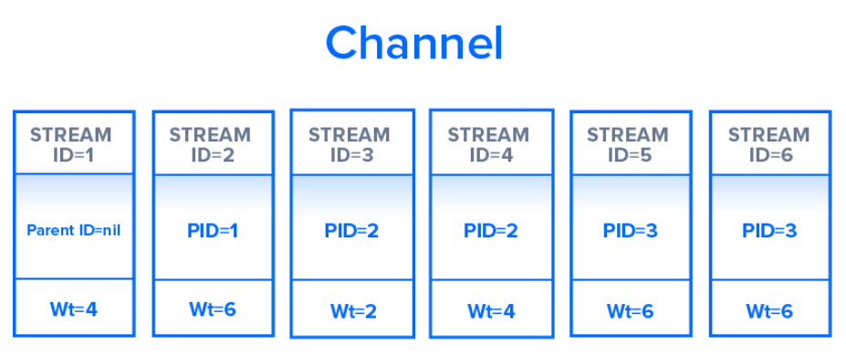

BUFFER OVERFLOW

* Buffer overflow happens when source send large amount of data which is higher than destination buffer size.
* **Receive window** – amount of space available at buffer.
* In HTTP1.1 flow control relies on TCP connection but in HTTP2 own flow control was implemented by communicating available buffer space and set **Receive window** on multiplexed streams.

RESOURCE REQUEST

* In HTTP1.1 **resource inlining** is performed, where initially client will send get request and receive index HTML page of site. By using Index page further request for css and JS will be made.
* In HTTP2 **server push** technique was used to push all required contents in a concurrent multiple response for single get request.

COMPRESSION

* In HTTP2 **HPACK** compression was used to shrink size of headers.

1. **Object and internal representation in javascript**

MEMORY ALLOCATION COMPARISON BETWEEN PRIMITIVES AND OBJECTS

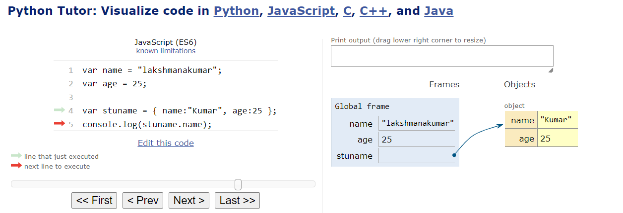

1. For primitive variables values will get stored directly in memory allocated for variable
2. Objects will not store value directly, it will store reference to value.

OBJECT CREATION WITH LITERALS

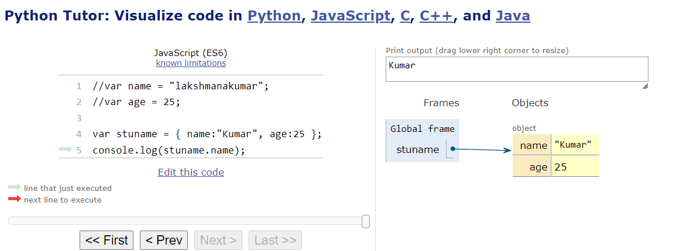

OBJECT CREATION WITH NEW KEYWORD

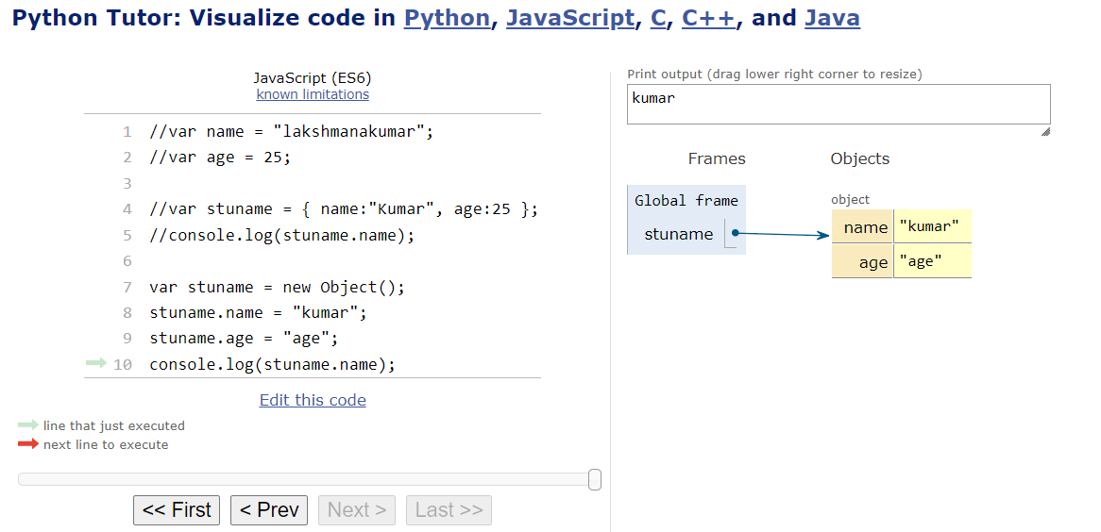

OBJECT CREATION WITH CREATE METHOD

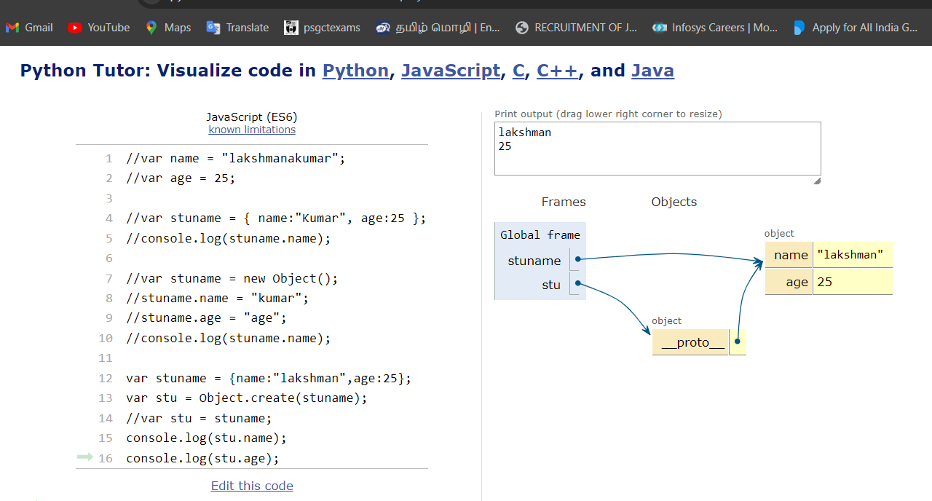

ACCESSING AND REINITIALIZING PROPERTIES BY DOT MEHTOD AND BRACKET ASSOCIATION

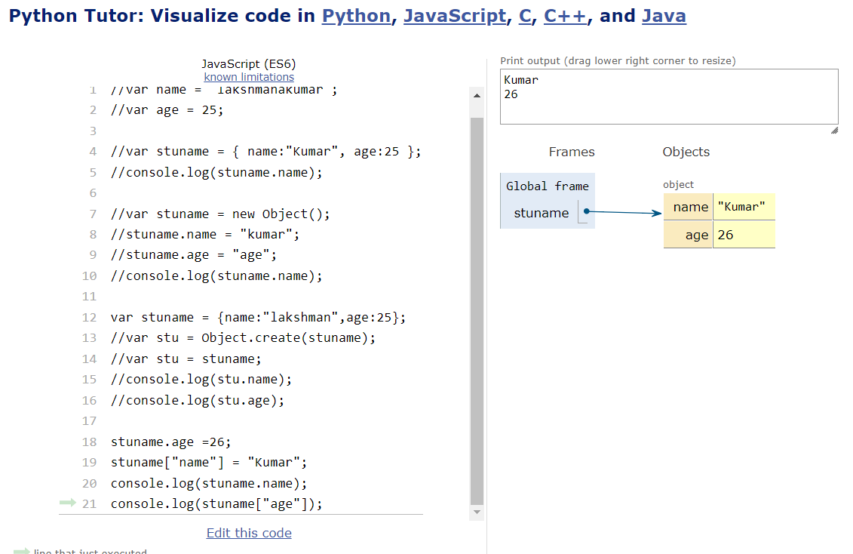

**REFRENCE**

<https://www.digitalocean.com/community/tutorials/http-1-1-vs-http-2-what-s-the-difference>

<https://en.wikipedia.org/wiki/Cipher_suite>

<https://en.wikipedia.org/wiki/HTTP>

<https://www.youtube.com/watch?v=jhqrRT4fvOA>

<https://www.youtube.com/watch?v=j9QmMEWmcfo>